Project Title: Real time -river water quality monitoring and control system Project Design Phase-I - Solution Fit

Template

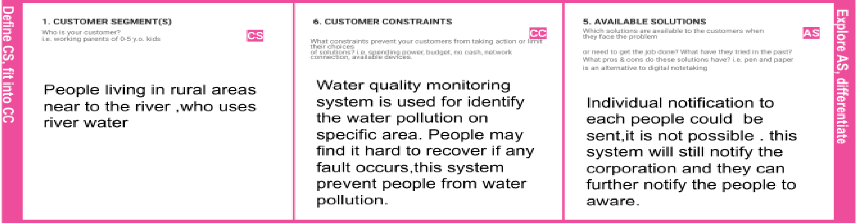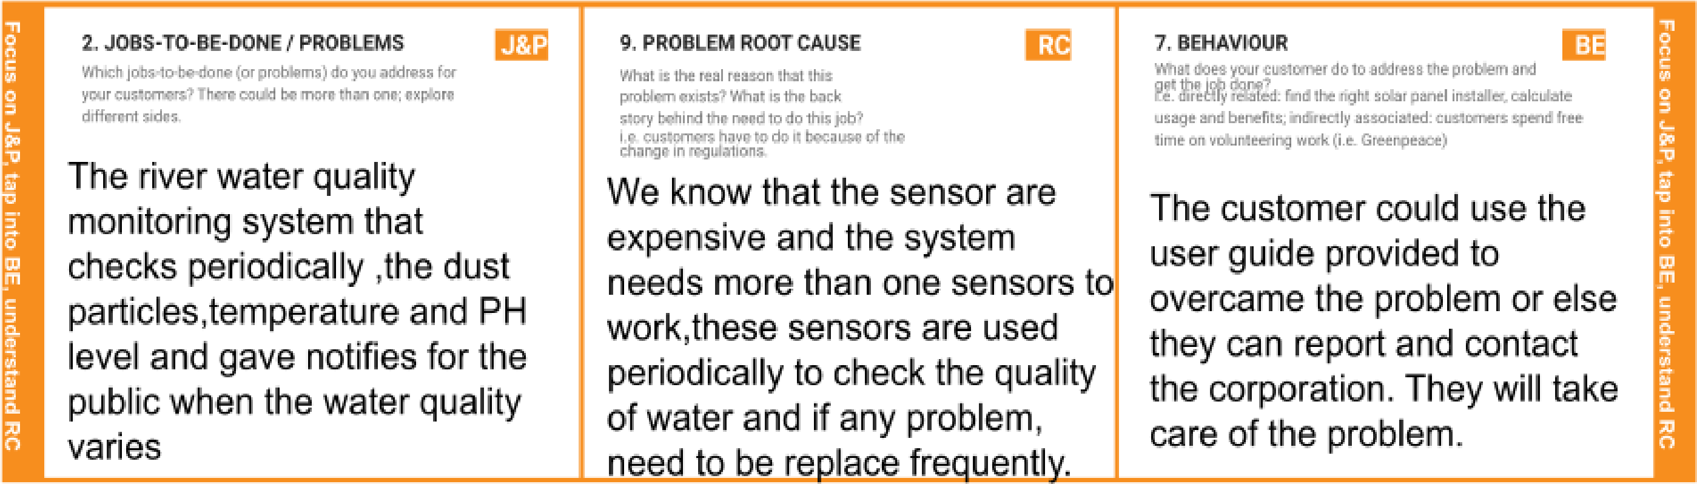

Team ID: PNT2022TMID53935

|  |  |  |  |  |  |
| --- | --- | --- | --- | --- | --- |
|  | 3. TRIGGERS  What triggers customers to act? i.e. seeing their neighbour installing solar panels, reading about a more efficient solution in the news.  if certain area people start using this quality monitoring system and so they are staying healthy without any disease and harmful algal blooms. thus will trigger the other affected area people to use this same system. | TR | 10. YOUR SOLUTION SL  If you are working on an existing business, write down your current solution first, fill in the canvas, and check how much it fits reality.  If you are working on a new business proposition, then keep it blank until you fill in the canvas and come up with a solution that fits within customer limitations, solves a problem and matches customer behaviour.  Altering the authorities if the water quality is not good . so that they can go and announce to the localities not to drink that water or live any living things. | 8.CHANNELS of BEHAVIOUR CH  8.1ONLINE  What kind of actions do customers take online? Extract online channels from #7  if it is in online mode , they can use mobile or any other sources to send the message  or contact authorities via helpline number.  8.2OFFLINE  What kind of actions do customers take offline? Extract offline channels from #7 and use them for customer development.  if it is in offline mode , the customers can directly reach the corporation office and report the problem. |  |
| 4. EMOTIONS: BEFORE / AFTER EM  How do customers feel when they face a problem or a job and afterwards?  i.e. lost, insecure > confident, in control - use it in your communication strategy & design.  the customer feels hard to recover their  problems ,but now we will guide them with a user  guide and they will find solutions to their problems. | |